RELAY DRIVER:
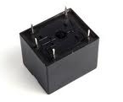
A relay driver circuit is a circuit which can drive, or operate, a relay so that it can function appropriately in a circuit.
The driven relay can then operate as a switch in the circuit which can open or close, according to the needs of the circuit and its operation.
In this project, we will build a relay driver for both DC and AC relays. Since DC and AC voltages operate differently, to build relay drivers for them requires slightly different setup. We will also go over a generic relay driver which can operate from either AC or DC voltage and operate both AC and DC relays.
All the circuits are relatively simple to understand.

DC Relay Driver Circuit
We will first go over how to build a relay driver circuit for relays which operate from DC power.
To drive a DC relay, all we need is sufficient DC voltage which the relay is rated for and a zener diode.
All relays come with a voltage rating. This is called on a relay's datasheet its rated coil voltage. This is the voltage needed in order for the relay to be able to operate and be able to open or close its switch in a circuit. In order for a relay to function, it must receive this voltage at its coil terminals. Thus, if a relay has a rated voltage of 9VDC, it must receive 9 volts of DC voltage to operate. So the most important thing a DC relay needs is its rated DC voltage. If you don't know this, look up what relay you have and look up its datasheet and check for this specification.
And the reason why a diode is needed is usually because it functions to eliminate voltage spikes from a relay circuit as the relay opens and closes. The coil of a relay acts an inductor. Remember that inductors are basically coils of wires wrapped around a conductive core. This is what relay coils are as well. Therefore, they act as inductors. Inductors are electronic components that resist changes in current. Inductors do not like sudden changes in current. If the flow of current through a coil is suddenly interrupted, for example, a switch opening, the coil will respond by producing a sudden, very large voltage across its leads, causing a large surge of current through it. From a physics or physical perspective, this phenomen is a result of a collapsing magnetic field within the coil as the current is terminated abruptly. Mathematically, this can be understood by noticing how a large change in current (dI/dt) affects the voltage across a coil (V=LdI/dt). Since we are opening the switch, in this case, the current literally goes from full mode to 0 instantaneously. This creates a large voltage spike. Surges in current that result from inductive effects can create very high voltage spikes (as high as 1000V) that can have nasty effects on neighboring devices with in the circuits, such as switches and transistors getting zapped. Not only are these voltage spikes damaging to other electronic components in a circuit but thye are also damaging to the relay's switch contacts. The contacts will suffer from these spikes as well.
The diode must be rated to handle currents equivalent to the maximum current that woudl have been flowing through the coil before the supply current was interrupted. Therefore, if the relay normally passes a certain amount of current through it during normal operation, the diode must be rated for a current rating above this value, as to not stop normal operation.

Components Needed
- DC Relay
- DC Voltage Source

Again, the DC relay must receive its rated voltage value in order to operate.
The DC power source can be either batteries, wall wart power, or a DC power supply- any DC power source.
The zener diode is placed reverse biased in parallel to the relay.

DC Relay Driver Circuit Schematic
Below is the DC relay driver circuit which we will build:
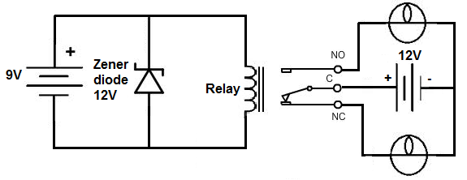
The relay which we use in this case is rated for 9V. Therefore, a 9-volt DC voltage source feeds the resistor. To suppress transients that may be caused by the relay opening and closing, we place a zener diode reverse biased in parallel with the relay. This will shunt all excess power to ground once it reaches a certain threshold. This is all that is needed to operate the relay. With sufficient power, the relay will now closed, driving the loads that are connected to its output.

Generic Relay Driver Circuit
The last relay driver circuit we will show is one which can be driven by an arbitrary control voltage.
This is a relay driver circuit which can be driven by either AC or DC input voltage. And unlike the other circuits, a specific voltage, such as the rated voltage values we used to drive the others, does not need to be used. Because this circuit contains a transistor, much less power needs to used on the input side to drive it.
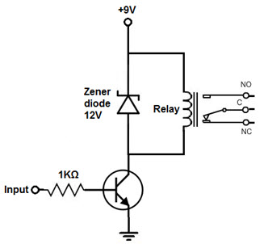
Relay Driver IC Circuit
In order to drive the relay, we use transistor and only less power can be possibly used to get the relay driven. Since, transistor is an amplifier so the base lead receives sufficient current to make more current flow from Emitter of Transistor to Collector. If the base once gets power that is sufficient, then the transistor conduct from Emitter to Collector and power the relay.
The Transistor’s emitter-to-collector channel will be opened even though no input current or voltage is applied to Base lead of Transistor. Therefore, blocking current flows through relay coil.
The emitter-to-collector channel will be opened and allows current to flow through relay’s coil if enough current or voltage is applied as input to the base lead. AC or DC Current can be used to power the relay and circuit.Relays are electromagnetic devices which allow low-power circuit to switch a high current ON and OFF switching devices with the help of an armature that is moved by an electromagnet.
Driver Circuit is used to boost or amplify signals from micro-controllers to control power switches in semi-conductor devices. Driver circuits take functions that include isolating the control circuit and the power circuit, detecting malfunctions, storing and reporting failures to the control system, serving as a precaution against failure, analyzing sensor signals and creating auxiliary voltages.

Advantages of Low Side Driver
More interface options are available which includes popular ULN2003 driver.
- Easy to interface to low voltage logic circuitry.
- Fewer components are used.
- Less expensive NPN drive transistors.
- Relay power reduces load on voltage regulator.
- It uses more commonly obtained NPN drive transistors.
- It is easier to interface relay.
- It is economic.
- Uses Industry standard technique.
The ULN2003 has internal clamp diodes. While these work OK in non-critical applications and it leads to rise of glitches.

Clamp Diode
The clamp, free-wheeling or commutation diode provides a path for the inductive discharge current to flow when the driver switch is opened. If not provided, it will generate an arc in the switch—while the arc will not generally damage a switch contact, it will cause contact degradation over time—and yes, it will destroy transistors—been there, done that. The diode requirements are non-critical and a 1N4148 signal diode will generally work OK in low power applications.
Avoid emitter follower drivers. If the relay is switched to OFF in 4007 diode eliminates back e.m.f and safe guards the transistor. ON status of the relay is indicated by LED.

DC Relay Driver IC Circuit
Let us see construction of relay driver circuit for relays that are operated from DC power. In order to drive a DC relay, DC voltage is needed in required quantity to rate a relay and a zener diode.Voltage is required for the relay to operate and to open or close its switch in a circuit. Relays exist with a voltage rating. This is known as relay’s datasheet to rate its coil voltage. For the function of relay, it must receive this voltage at its coil terminals. Thus, if a relay has a rated voltage of 9VDC, it should get 9 volts of DC voltage for its working. In order to eliminate voltage spikes from a relay circuit, a diode is required for its proper functioning. The coil of a relay acts an Inductor.
